**Project 1 Report**

1. Introduction:

This project deal with the data analysis of a data given by “Surprise Housing Society” which aims at a predictive analysis of the Sales Price of the houses based on the given basic features. This information will be important to help customers who aim to buy houses under this society.

With context to industry, data science will be the most useful tool in helping to predict the Sales Price so that the firm can decide on what precises to put up for each house with the certain features. This is because data science will train a machine learning on the given data and eventually help predict the Sale Price of the house from using it.

1. Problem Statement:

* The data of a “Surprise Housing Society” is given. Information necessary to flats been provided.
* Using this data, we have to build a model that gives the Sales Price of the houses.
* There are various features which have been given in the dataset and will play a impacful role in predicting the values. We will identify their correlation with target variable to see the importance.

1. Data Collection and Preprocessing:

* The given data contains a training dataset and a testing dataset separately where data_train has 1168 rows and 81 columns and the data_test has 292 rows and 81 columns.
* This dataset is a Regression data.
* The data has been checked thoroughly for all the necessary information using info(), describe() functions.
* Missing values have been checked by using a user-defined function and it is found that no single row contains any null value.



* This data has 39 categorical variables and rest numerical variables.
* This was further divided to discrete and continuous data variable columns.

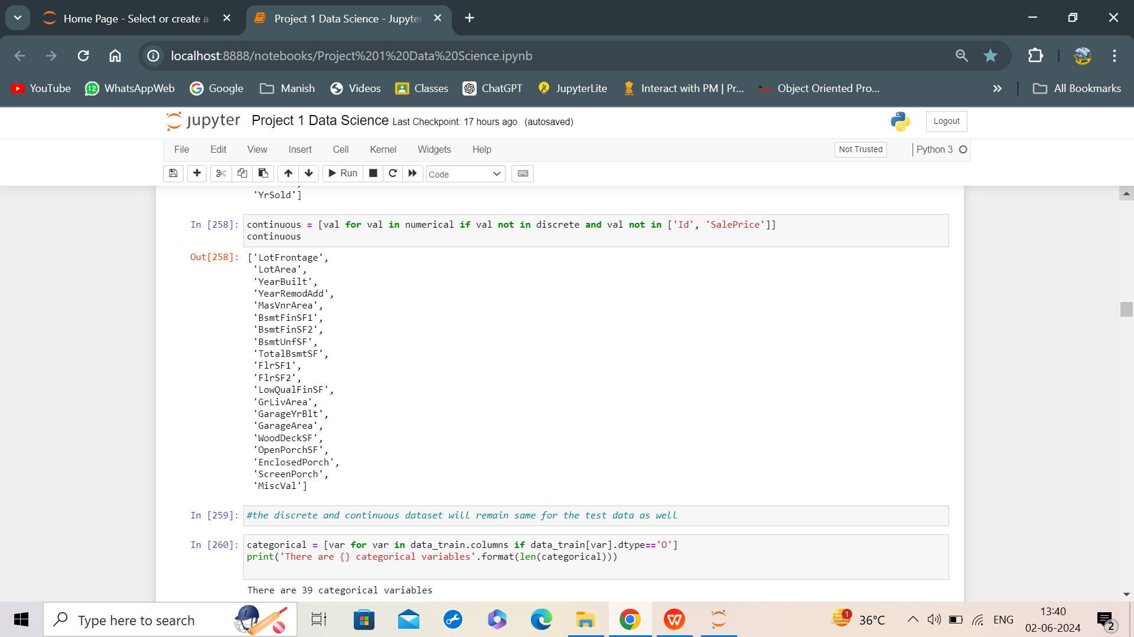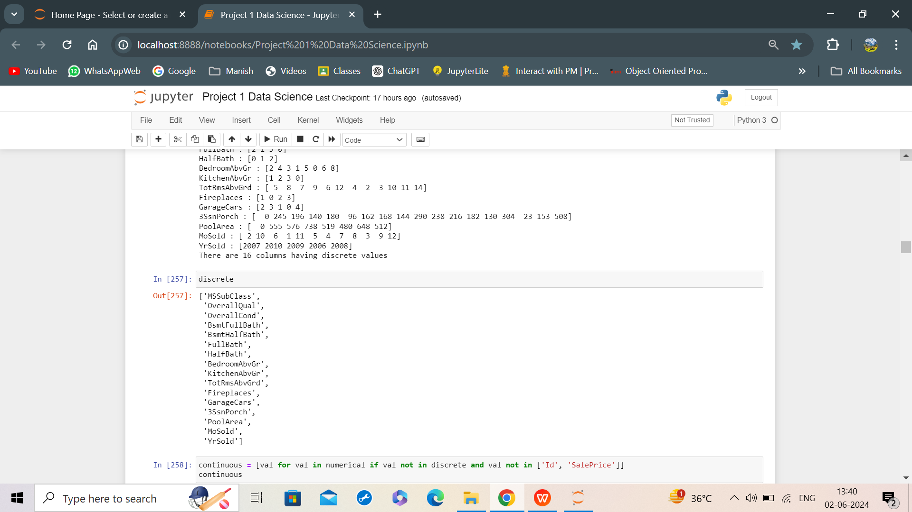

* PoolQC, Fence, Alley and MiscFeature columns were dropped because they had more than 50% Nulls.
* Missing Value in GarageType, GarageYrBlt, GarageQual, GarageCond were seen to be in the same row and hence these rows were imputed with none. Similarly, this was done for FireplaceQu with respect to Fireplaces and all the basement variables which had missing values. The values in MasVnr were imputed with the mode while those in LotFrontage were done with Median and Electrical column was imputed with median.

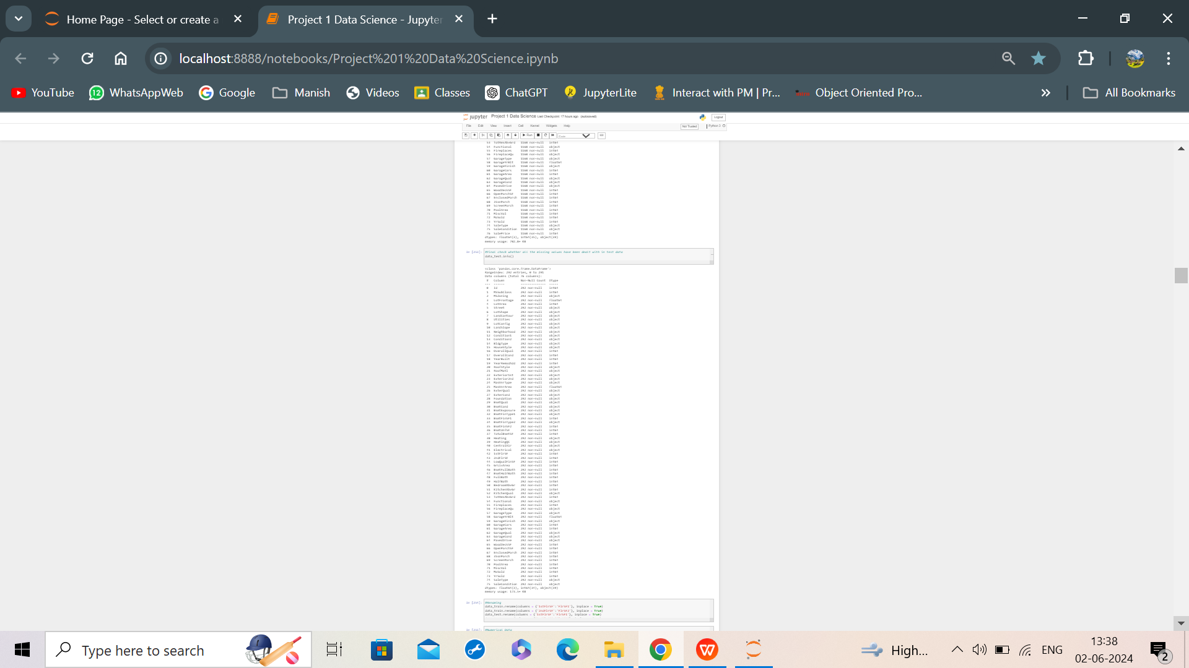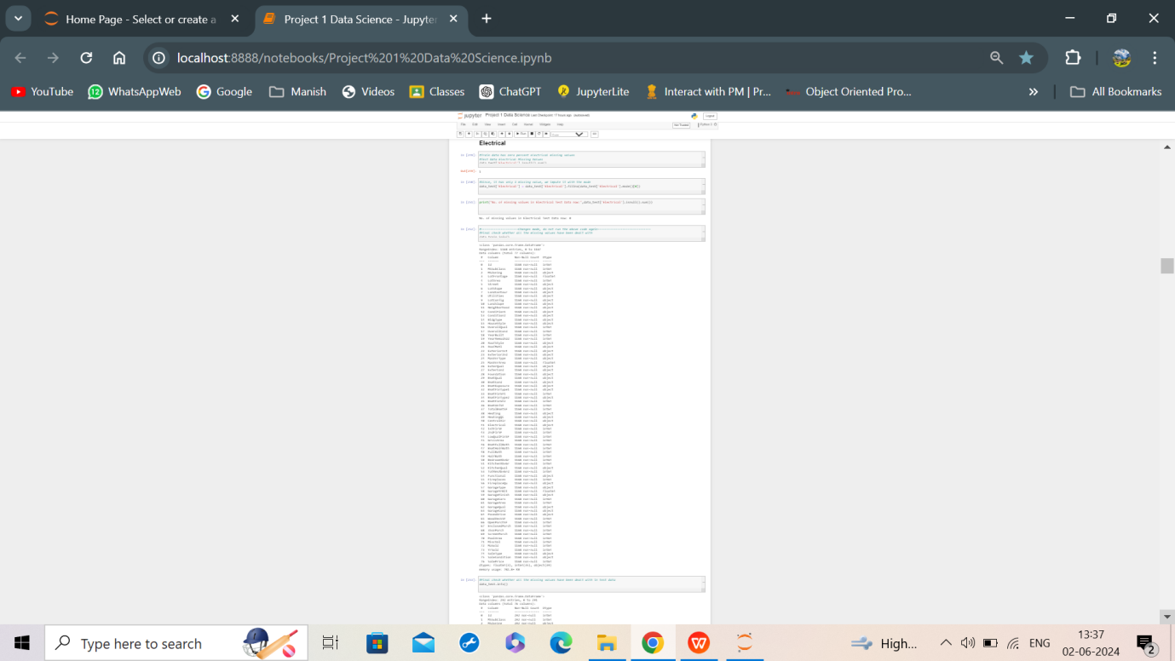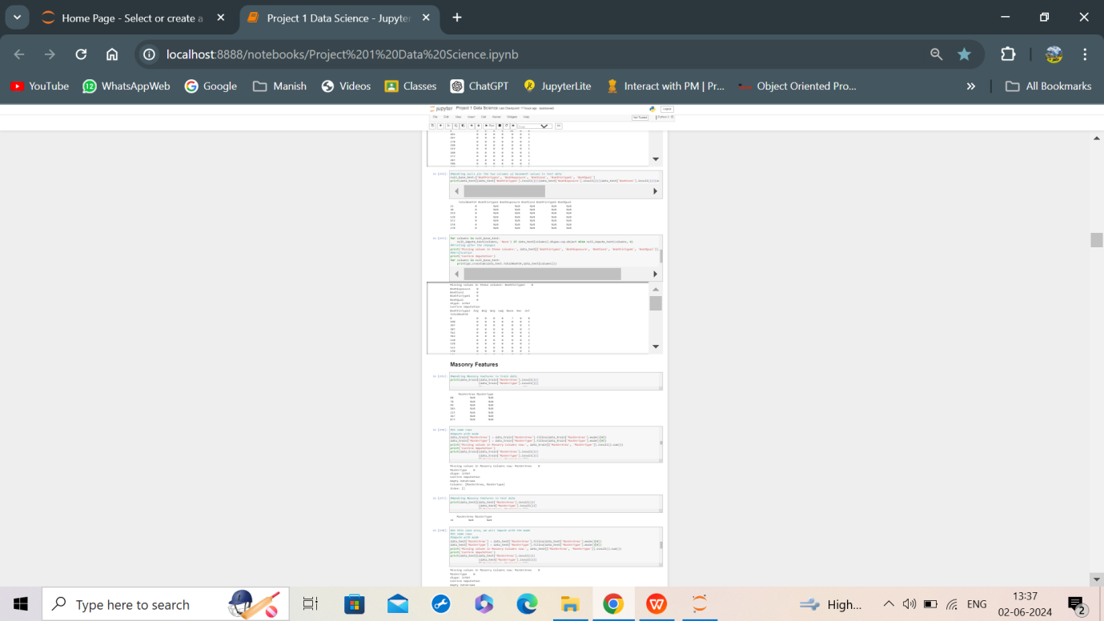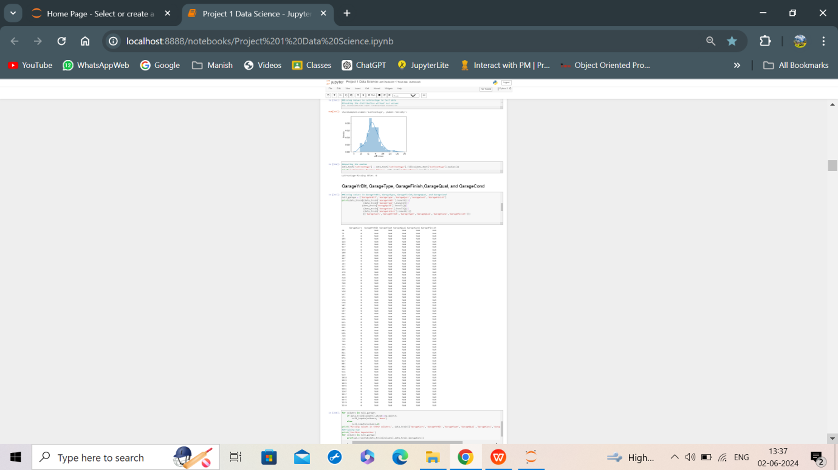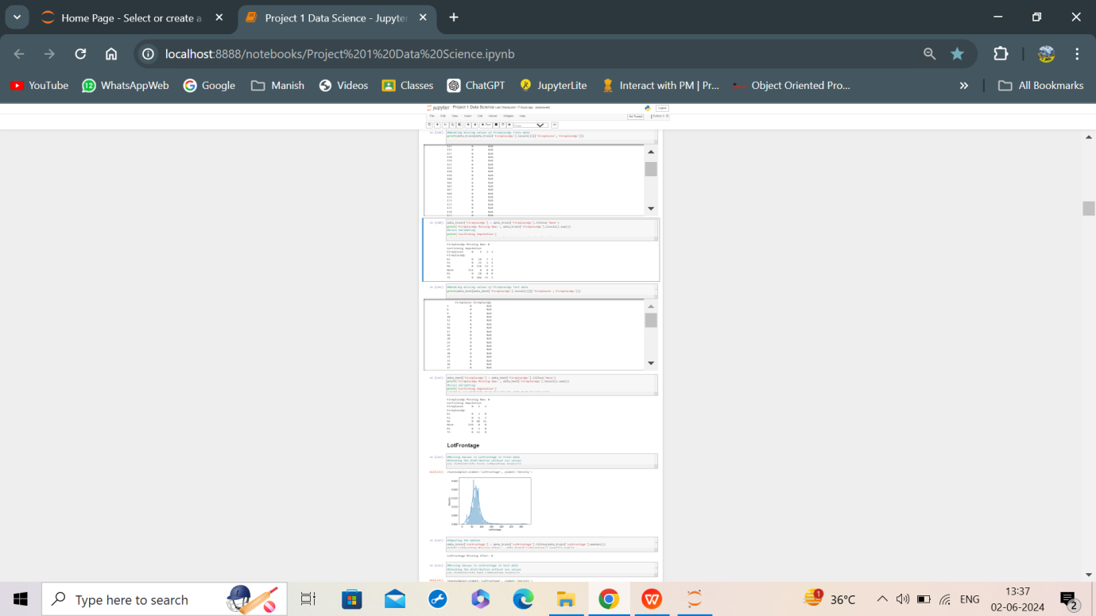

* In both the data sets, ordinal data was encoded by manual mapping and the rest was encoded by LabelEncoder.

The data can be further distributed to discrete and continuous dataset. Since, for most of the discrete value columns, the generic no. of unique values was found to be below 110, the two data sets have been separated using if condition as the above.

* The Outliers were checked for continuous and discrete variables and were capped using IQR method and Binning respectively. Resetting the index in IQR would make processing easier.
* The Distribution was normalized using “Yeo-Johnson” Method in PowerTransformer.
* The outliers capped boxplot and normalized distribution was checked again. Few snippets of the output is given below.

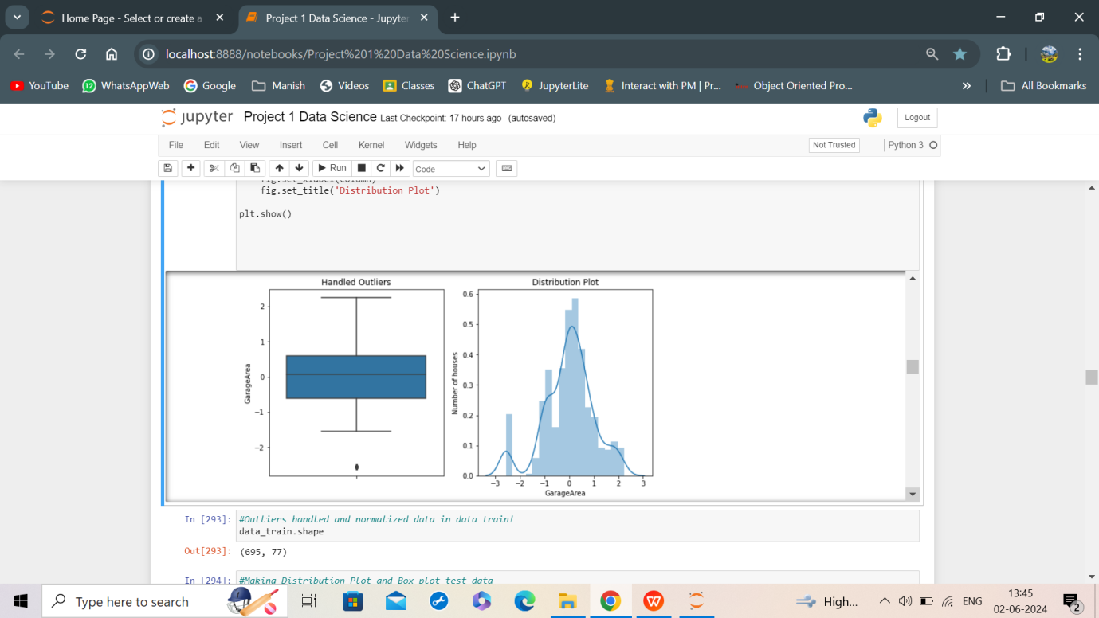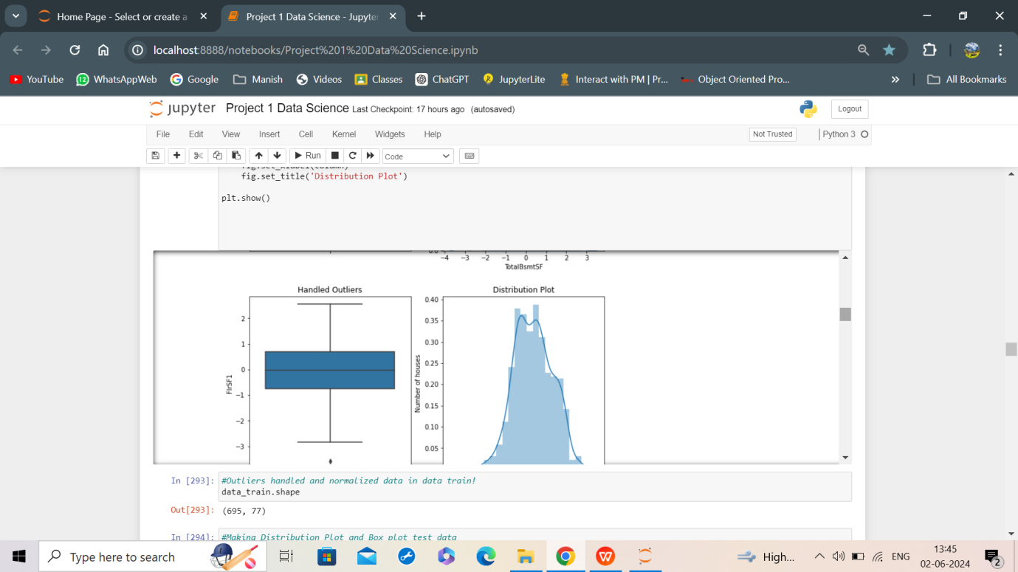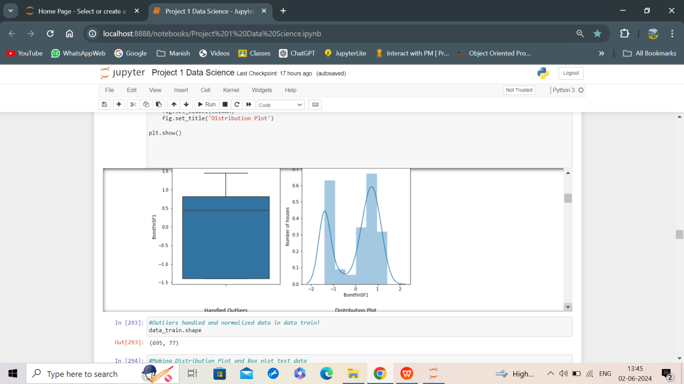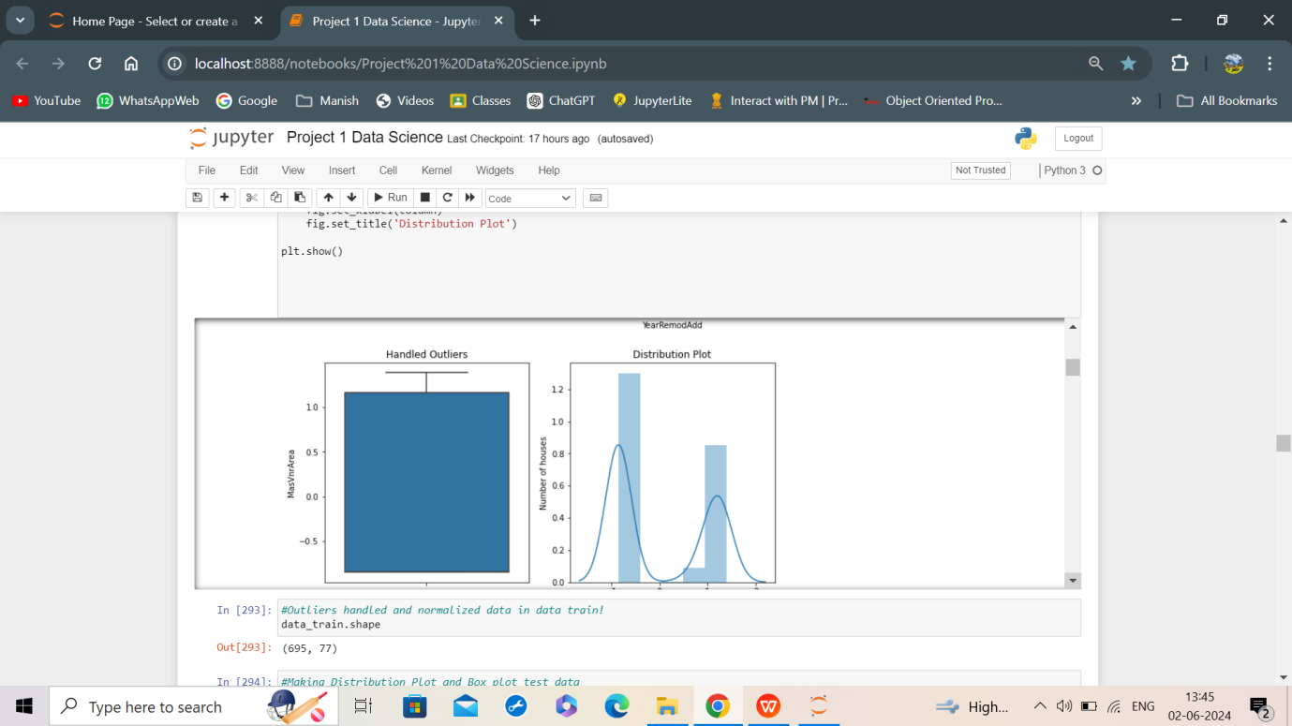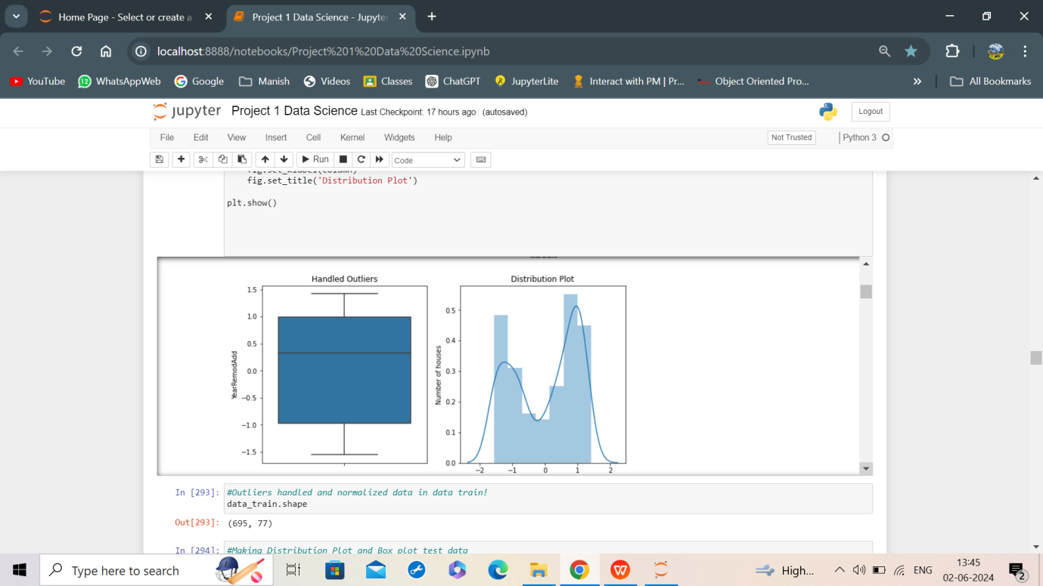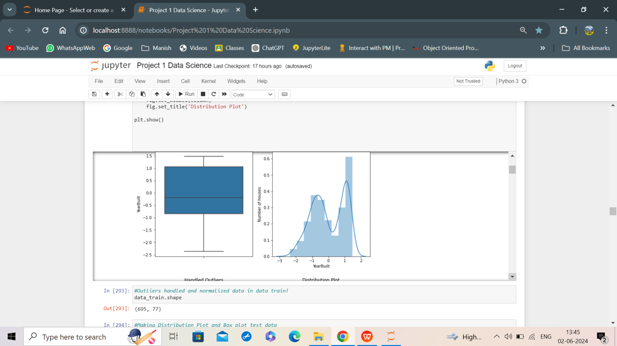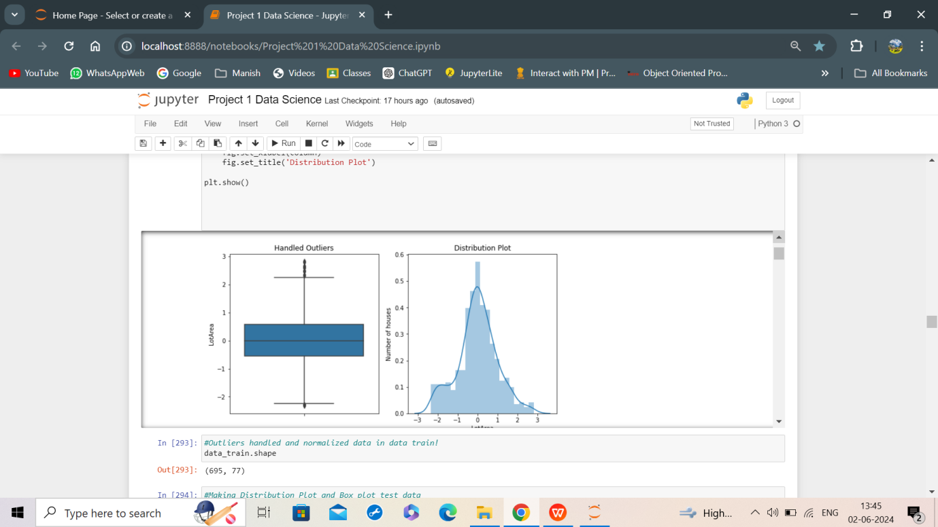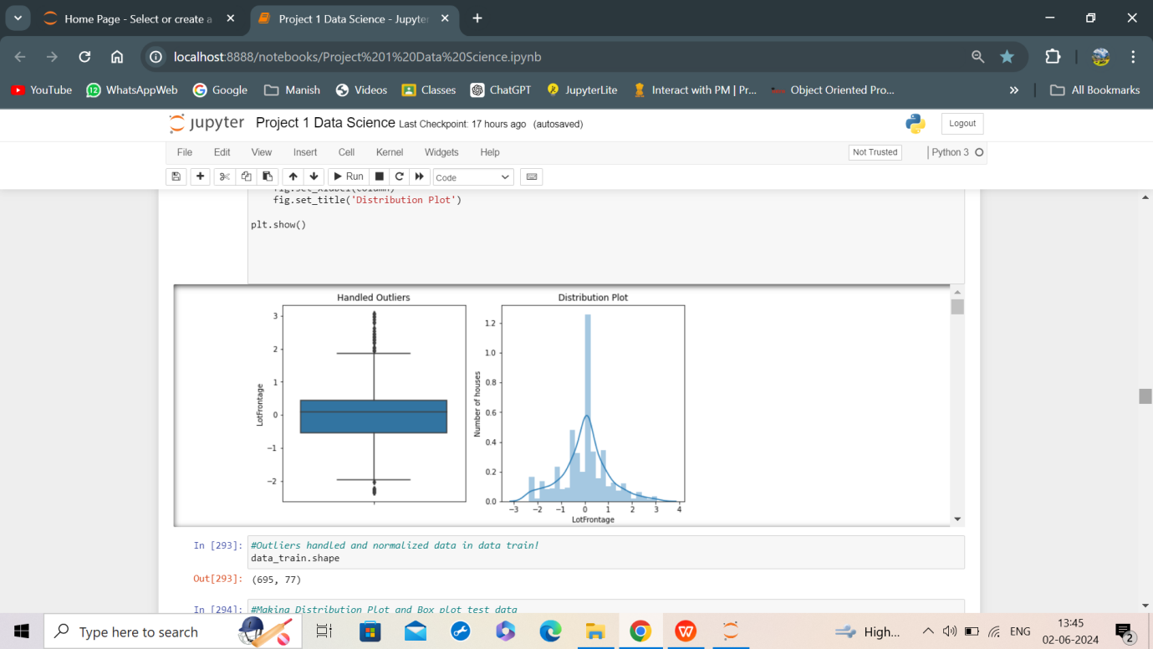

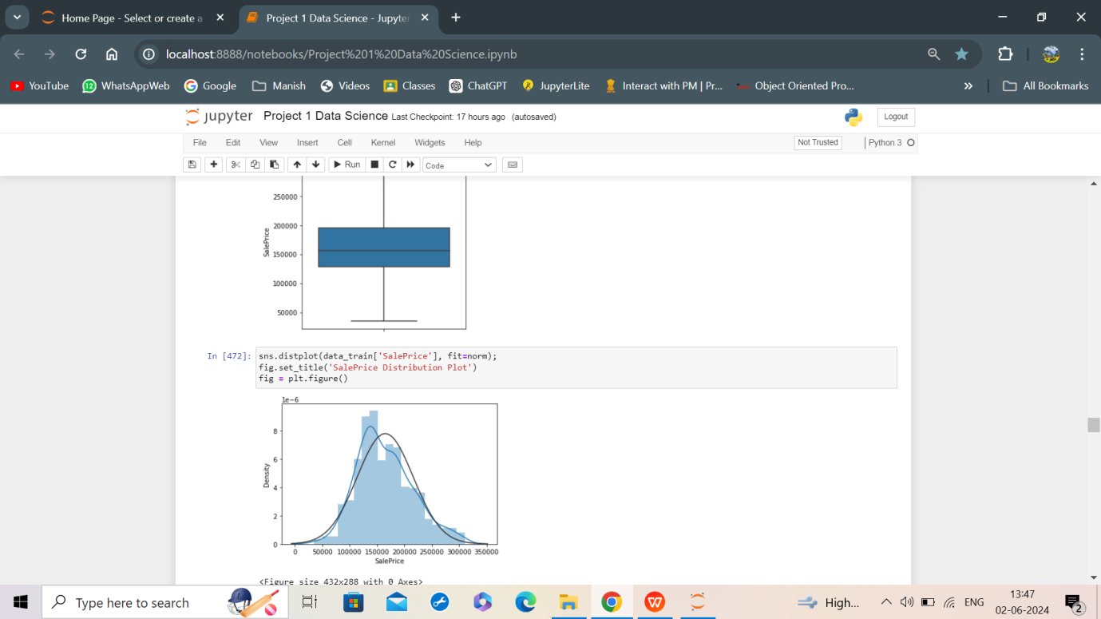

* The same was done for test data.
* After this Standardization(Feature Scaling) was done using StandardScaler() from sklearn.preprocessing library. The variable x_train_p and was created for scaled train data and x_test_p for trained data.
* To reduce the collinearity among independent variables, VIF value was checked.

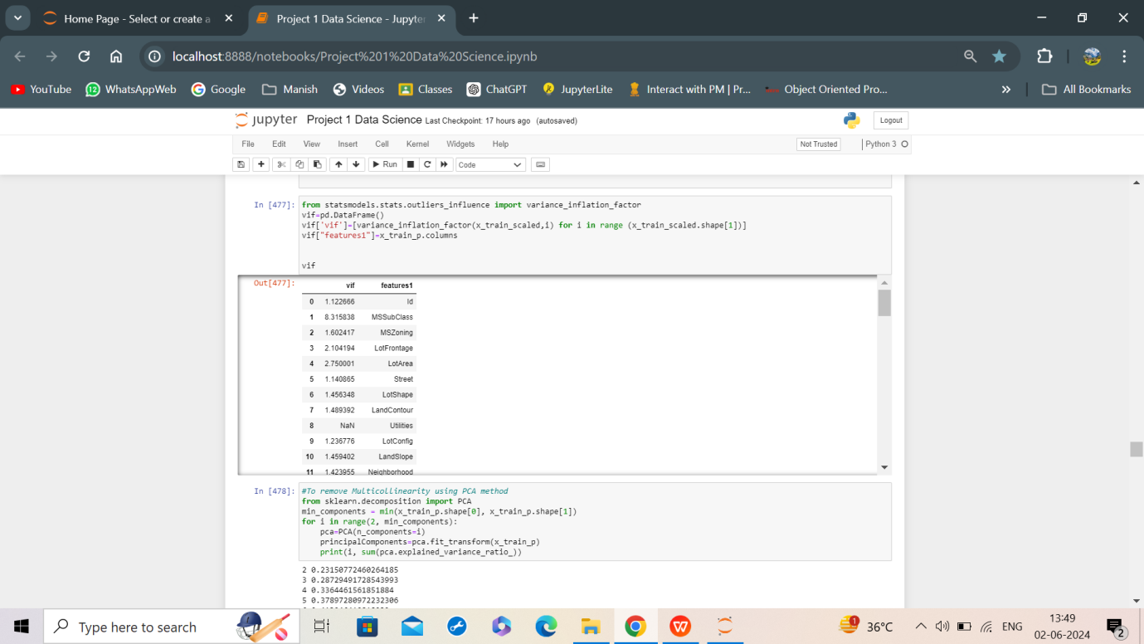

* The PCA Method was used for removing the collinearity and 95% data was found at 49=n_component and hence 49 principal features were created in train data and the same was done to maintain consistency with test data.

1. Exploratory Data Analysis

* Since, the dataset size is very huge so doing univariate analysis was done on few test data continuous features.

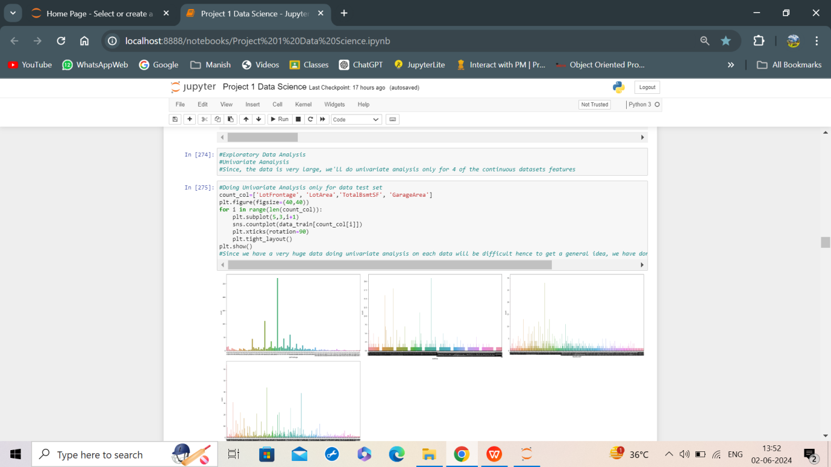

* Thus, we do Multivariate Analysis with the continuous dataset and discrete dataset using pairplot.

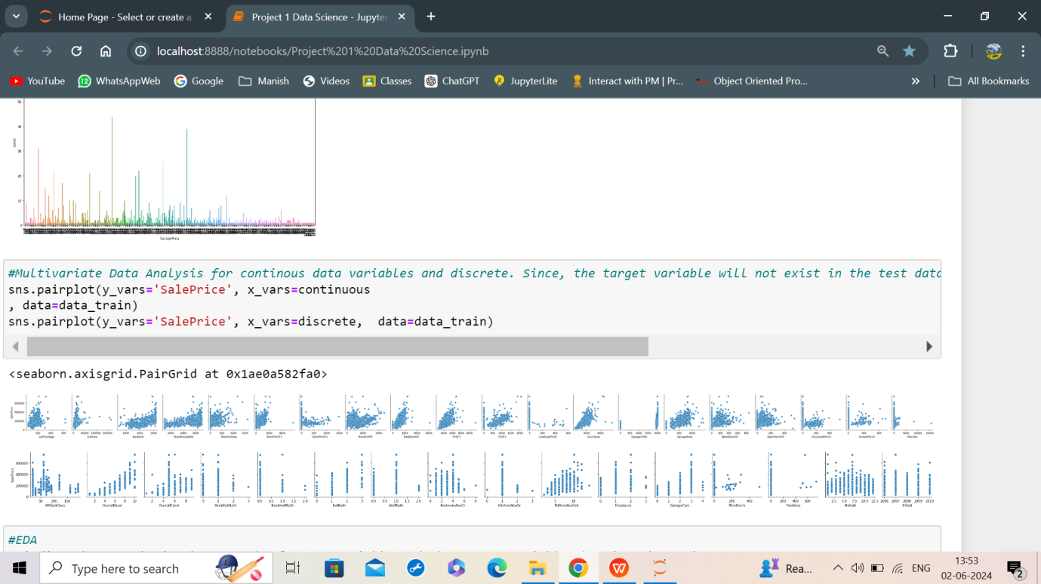

The output of few variables is pasted below:

Similarly, this can be seen for other continuous variables as well.

* The pairplot for many features were continuous however for some it wasn’t like halfbath, fullbath or PoolArea
* Next, plotting a heatmap which represented the multicolinearity between different feature columns.

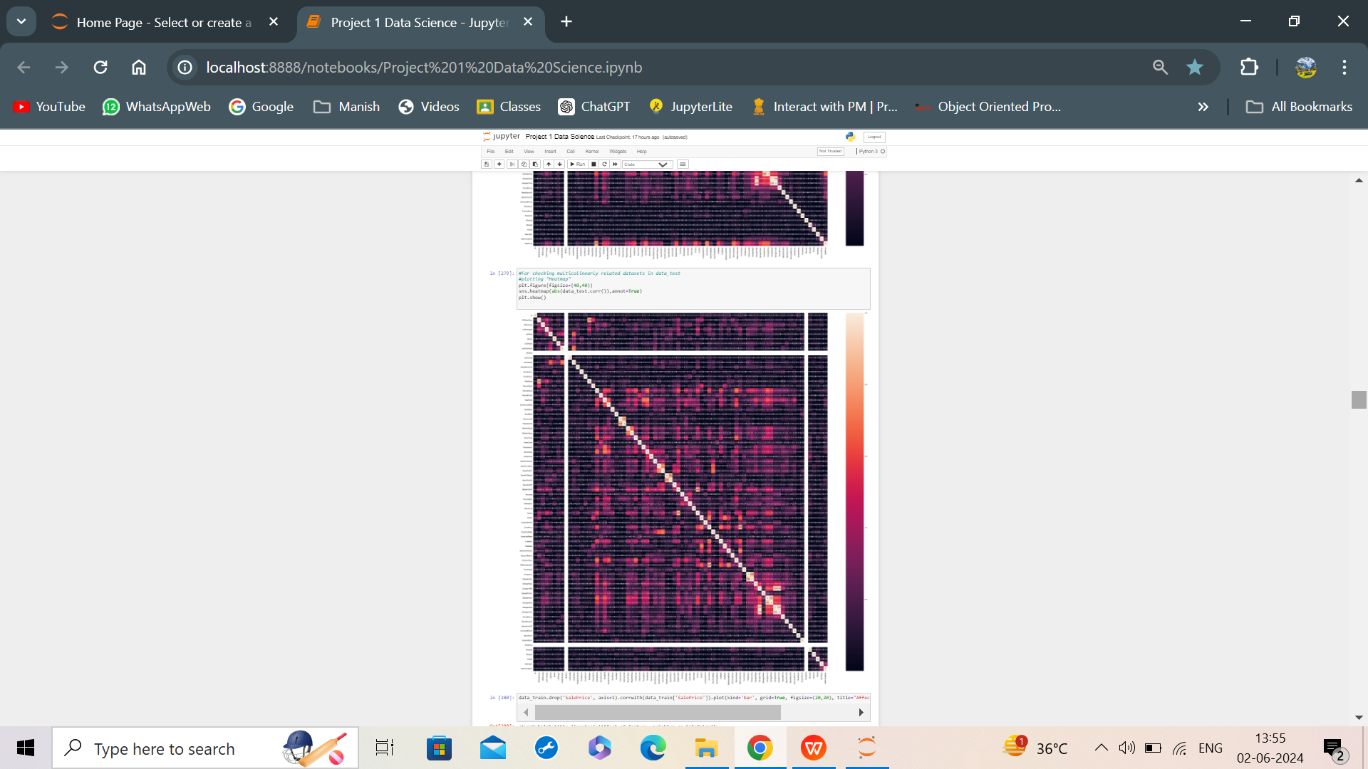

* In the heatmap, the lighter blocks portrayed high correlation between the two independent columns. High correlation was seen in columns which showed same value over different number of days such as, 0.82 between GrLivArea and TotRmtAbvr.
* No correlation was shown by Utilities.

The correlation of all the feature variables before capping the outliers was done with target variable, which helped us identify the first 5 most important variables with the highest correlation. These were: TotalBsmtSF

GarageArea

BsmtQual

GarageCars

KitchenQual

GrLivArea

OverallQual

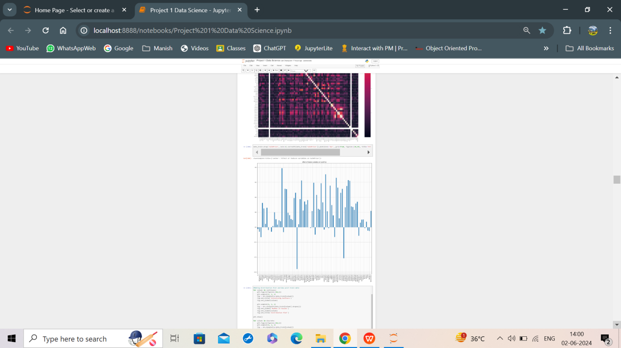

* We can infer from the graph that:

1. Some of the Features that Negatively affected the target variable were Garage Type, ExternQual, LotFrontage.
2. The variables, PoolArea and BsmtFinSF2 showed almost no affect on target variable.
3. Most of the features had positive influence on the target variable.

* The box plot and distribution plot analysis was done for all features. The output snippets are as below for some of the features.

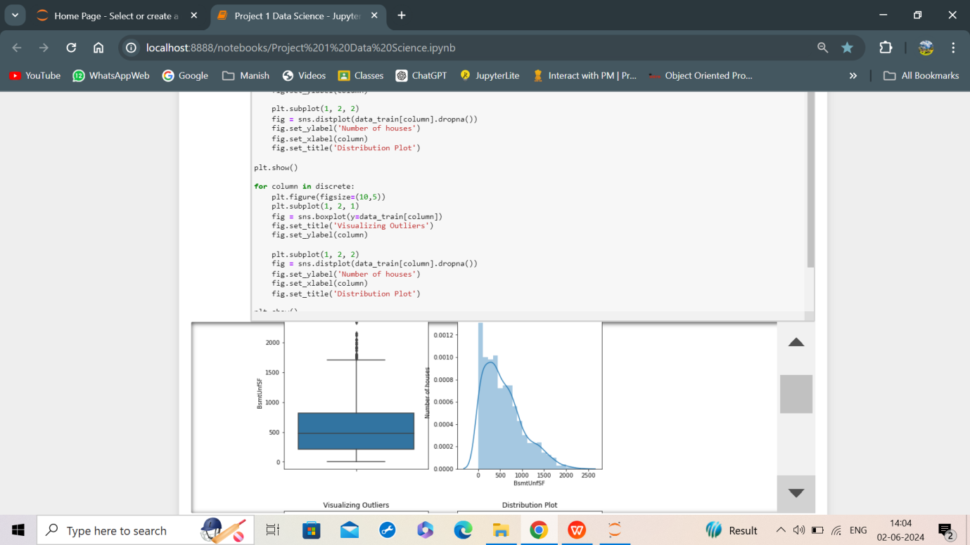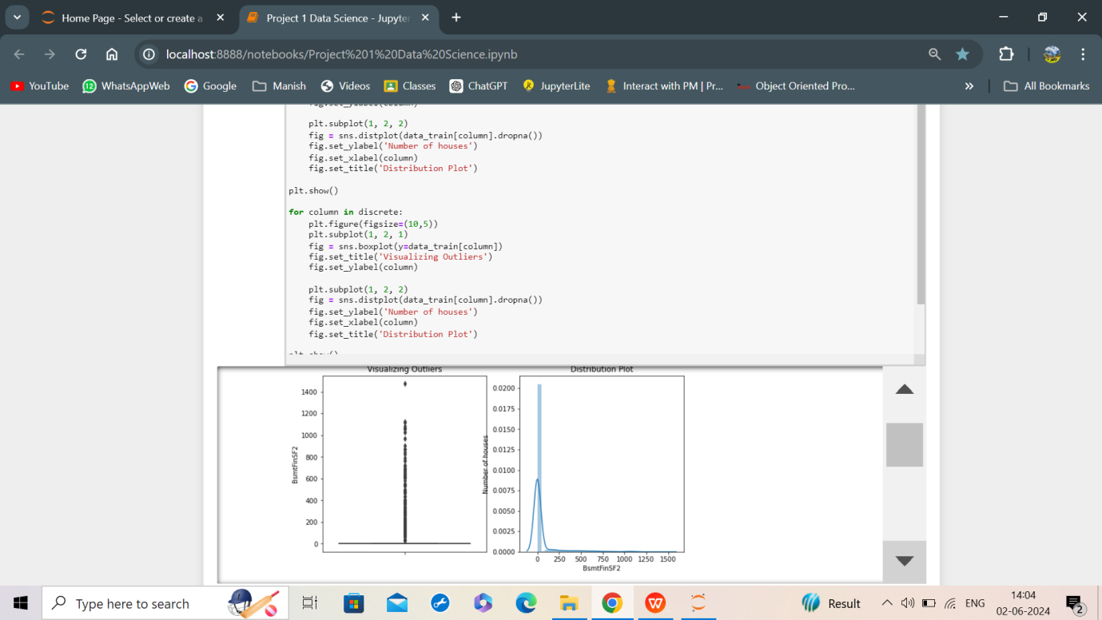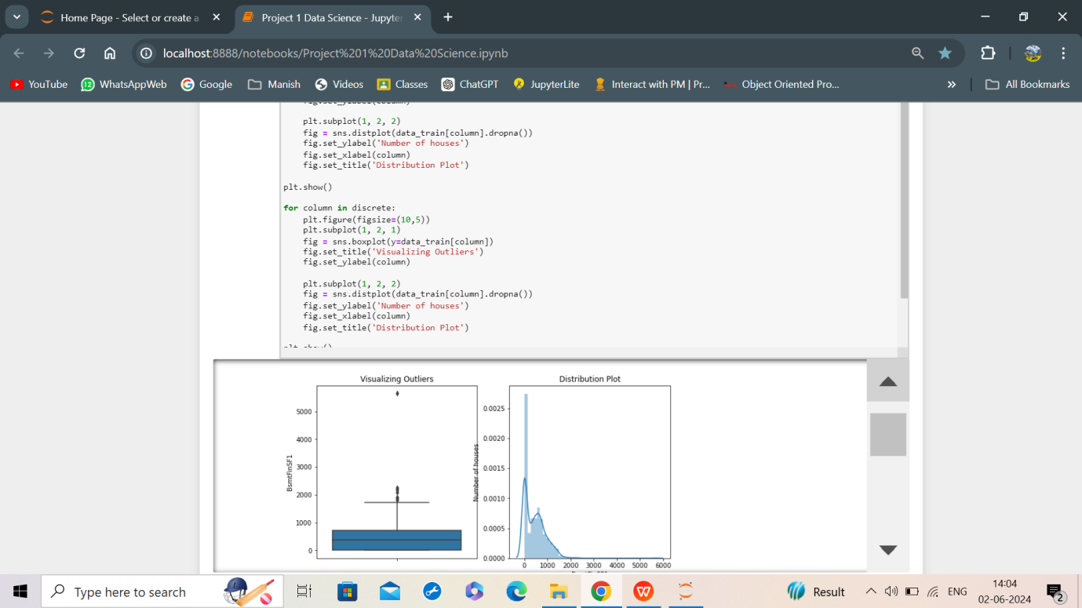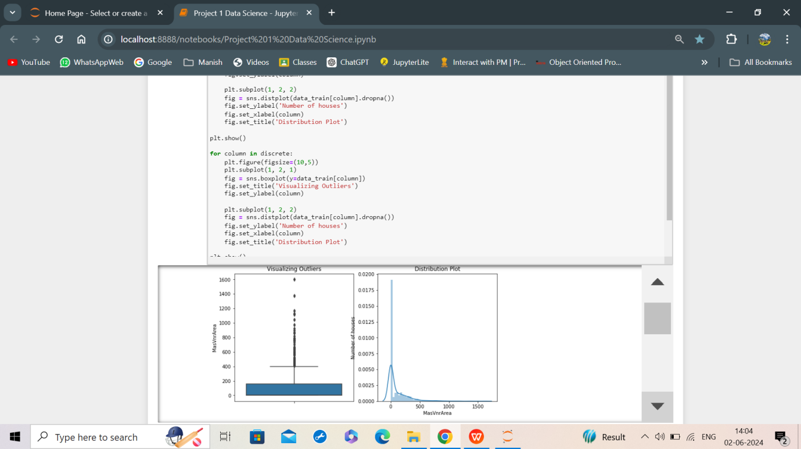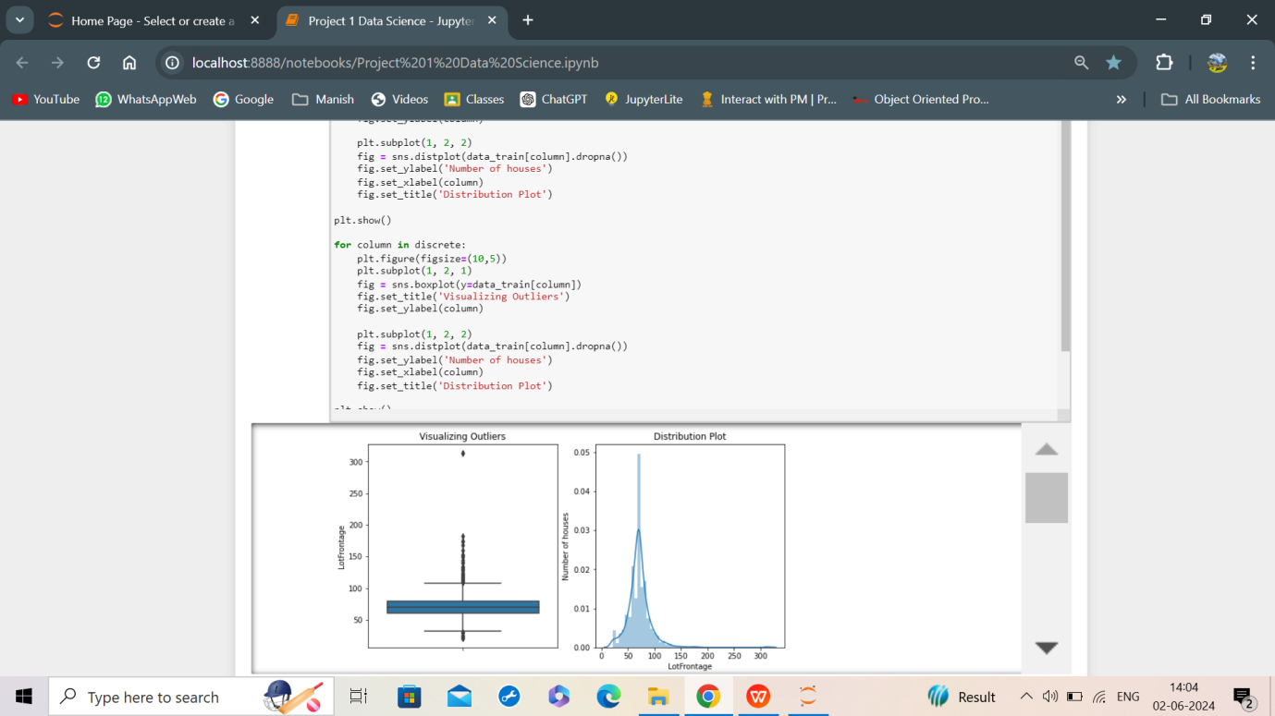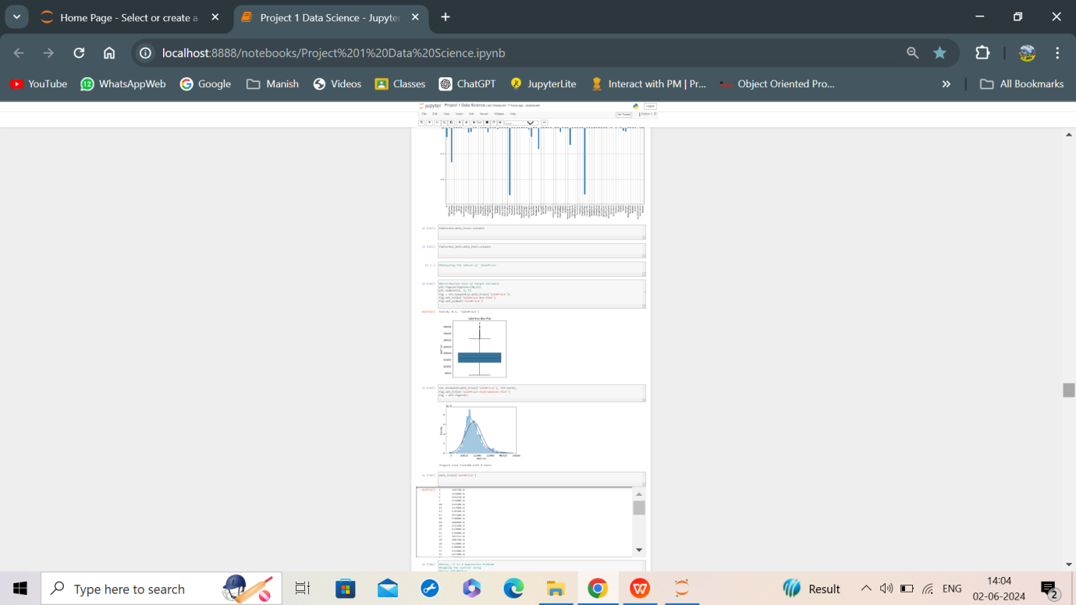

Feature Engineering

* New Features were created.

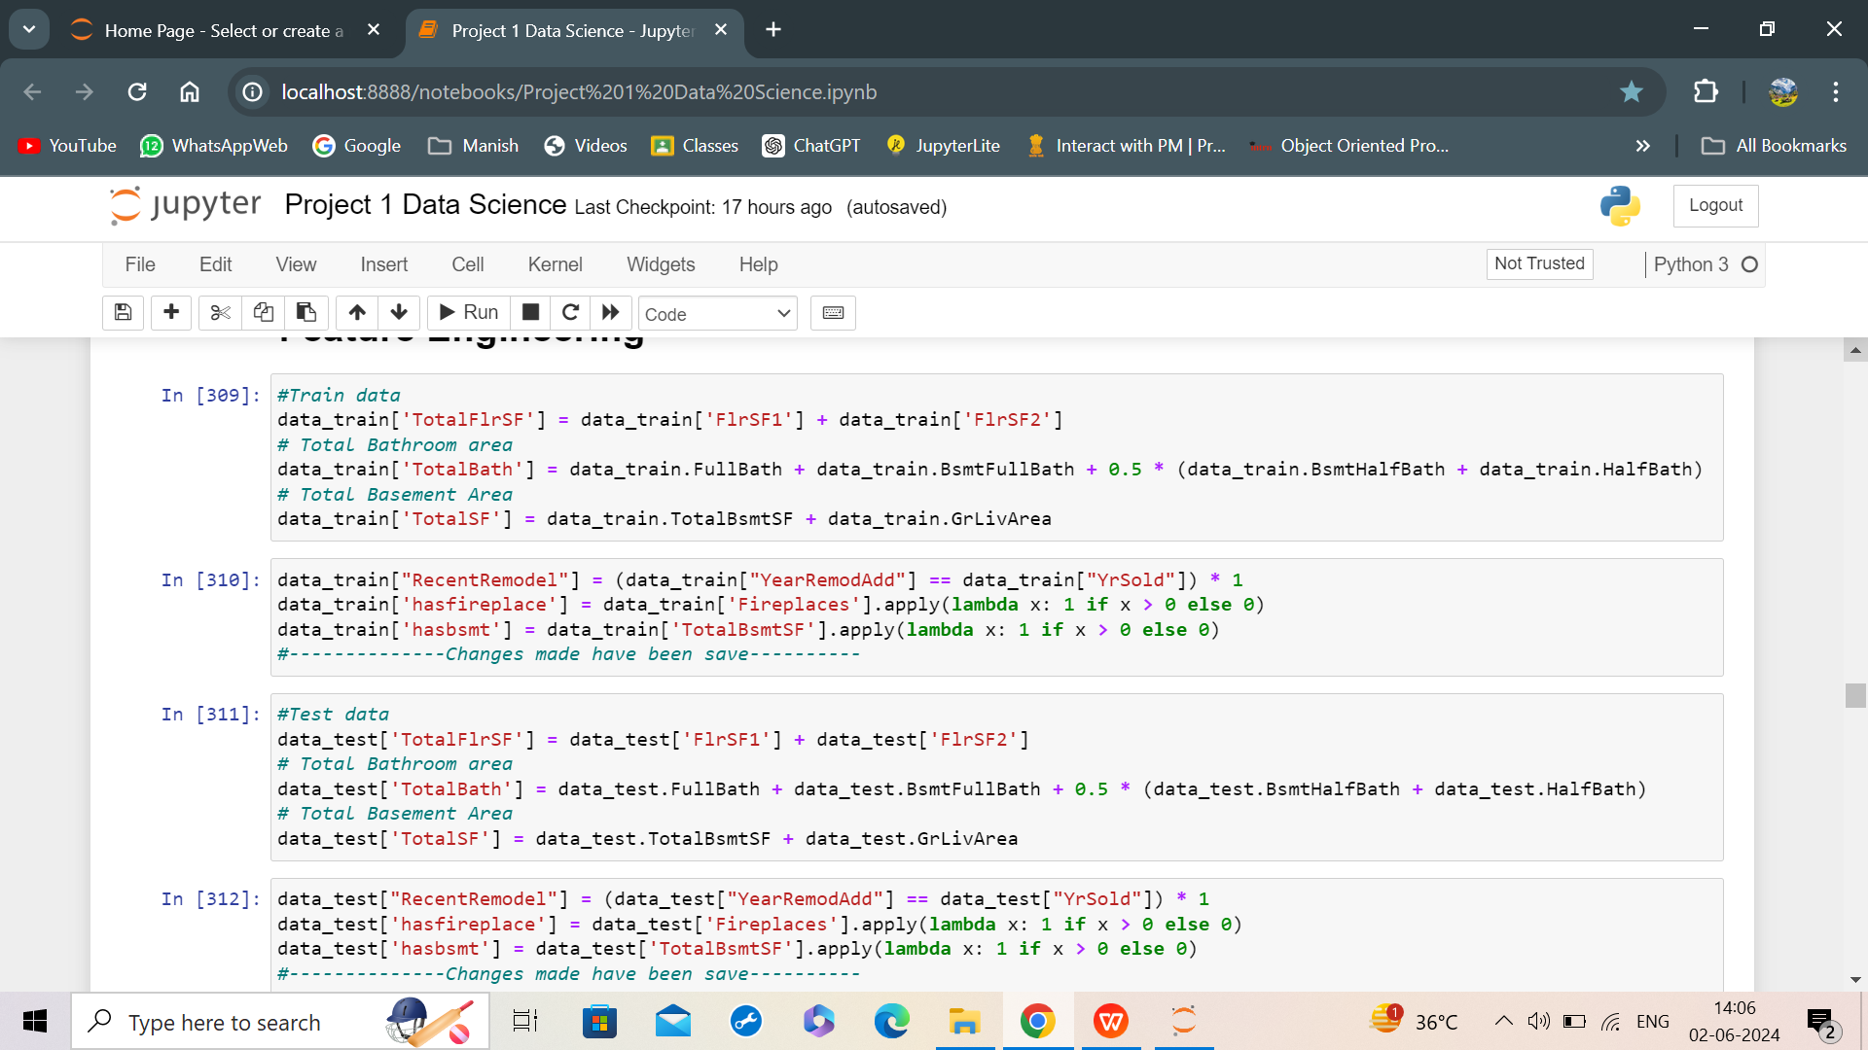

Model Selection and Training

* Of All the Random States, the random state chosen was 996 with the best testing accuracy.
* Models Selected were:

1. Linear Regression: This is a faster method and a very efficient method for Regression Problems..
2. GradientBoostingRegressor: Since, our data needs regression model and hence GradientBoostingRegressor will serve the purpose as it can work very well on such a datset. These can also handle overfitting.
3. Ridge: This method is a L2 type regulation. Handles errors and overfitting and is quite quick and efficient for regression datatype.
4. RandomForestRegressor: Since, our data needs regression model and hence RandomForestRegressor is also a regressor method and will do the purpose. RandomForest splits into a multiple decision tree structures. It is useful for such heavy amounts of data.
5. XGBRegressor: The xgboost method can be clearly used for large amount of data, can handle overfitting easily, has great accuracy with faster processing even for classification data and works well for such a data.

Hyperparameter Tuning:

* The RandomizedSearchCV Technique was used for hyperparametric tuning of the data as this data set is very huge and using GridSearchCV wouldn’t have been a good option.
* Optimal parameters chosen for each model have been presented along with the output below as best parameters.

Model Evaluation

* The evaluation metrics used are r2 score, mean_absolute_error, MSE, RMSE and learning curve plot using scikit-learn module

1. LinearRegression Model along with hyperparametric tuning results-

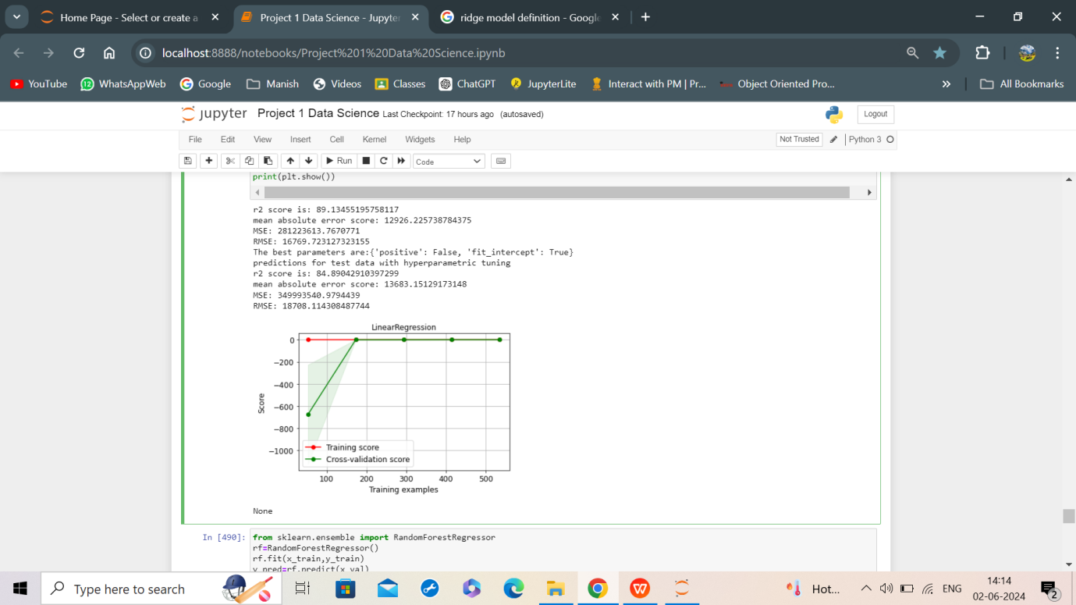

1. Gradient Boosting Model along with hyperparametric tuning results-

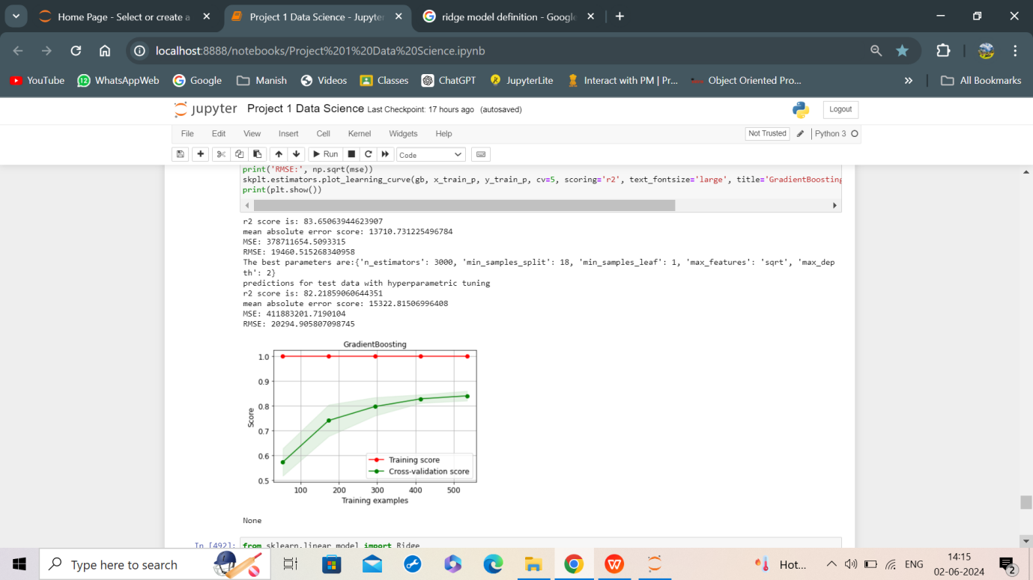

1. Ridge Model along with hyperparametric tuning results-

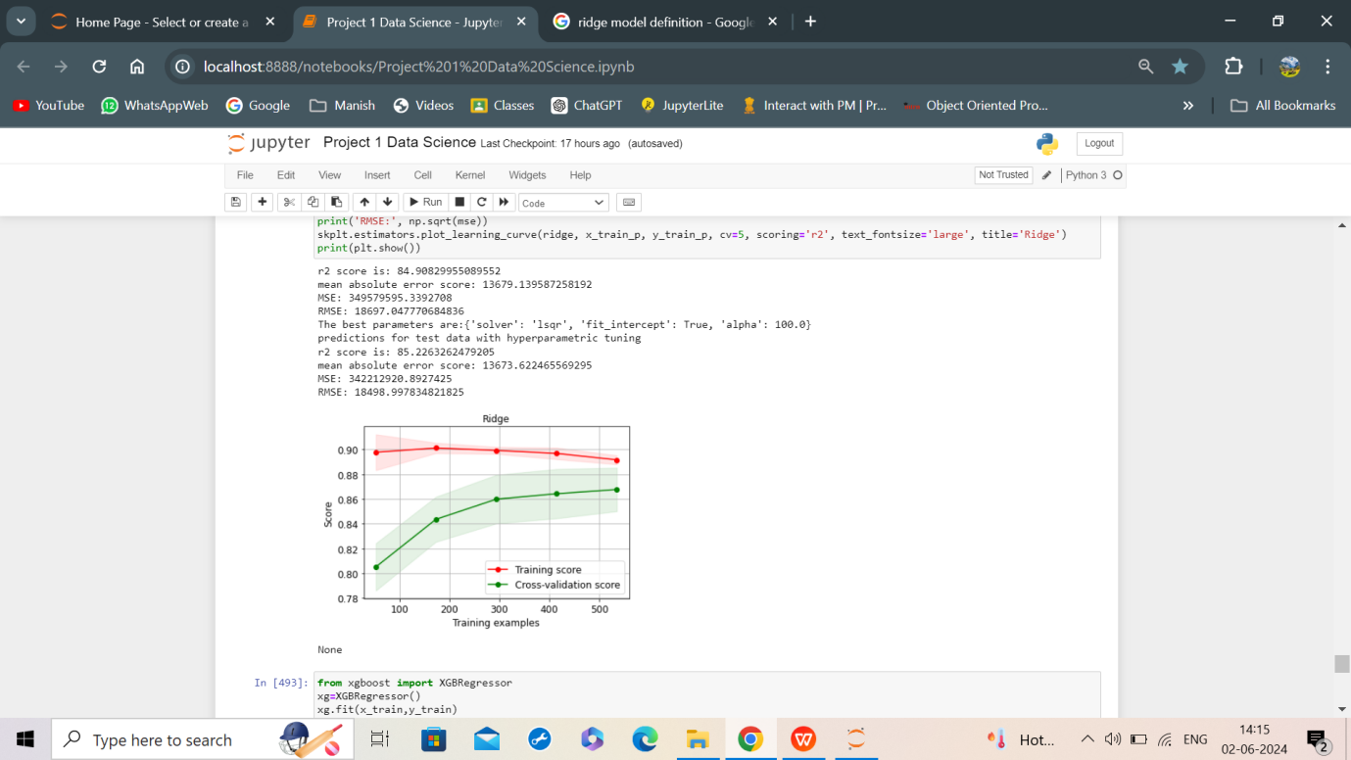

1. RandomForest Model along with hyperparametric tuning results-

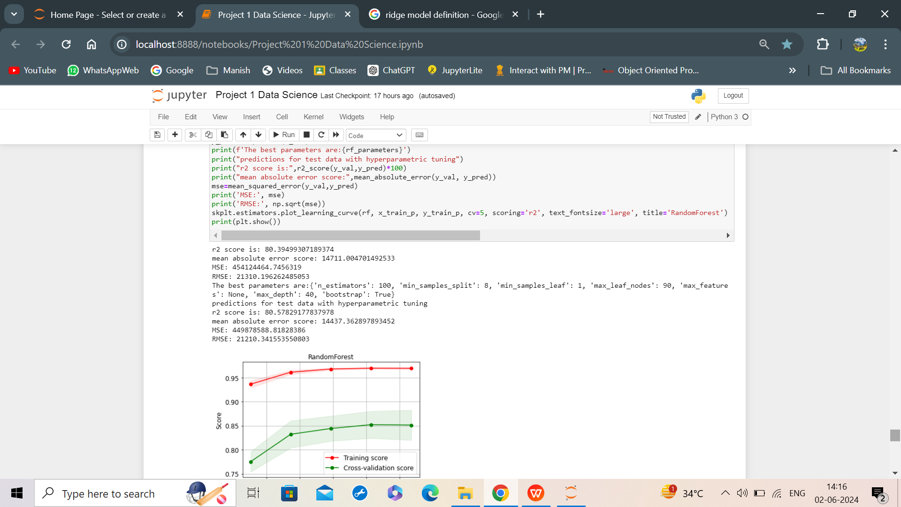

1. XGBoost Model along with hyperparametric tuning results-

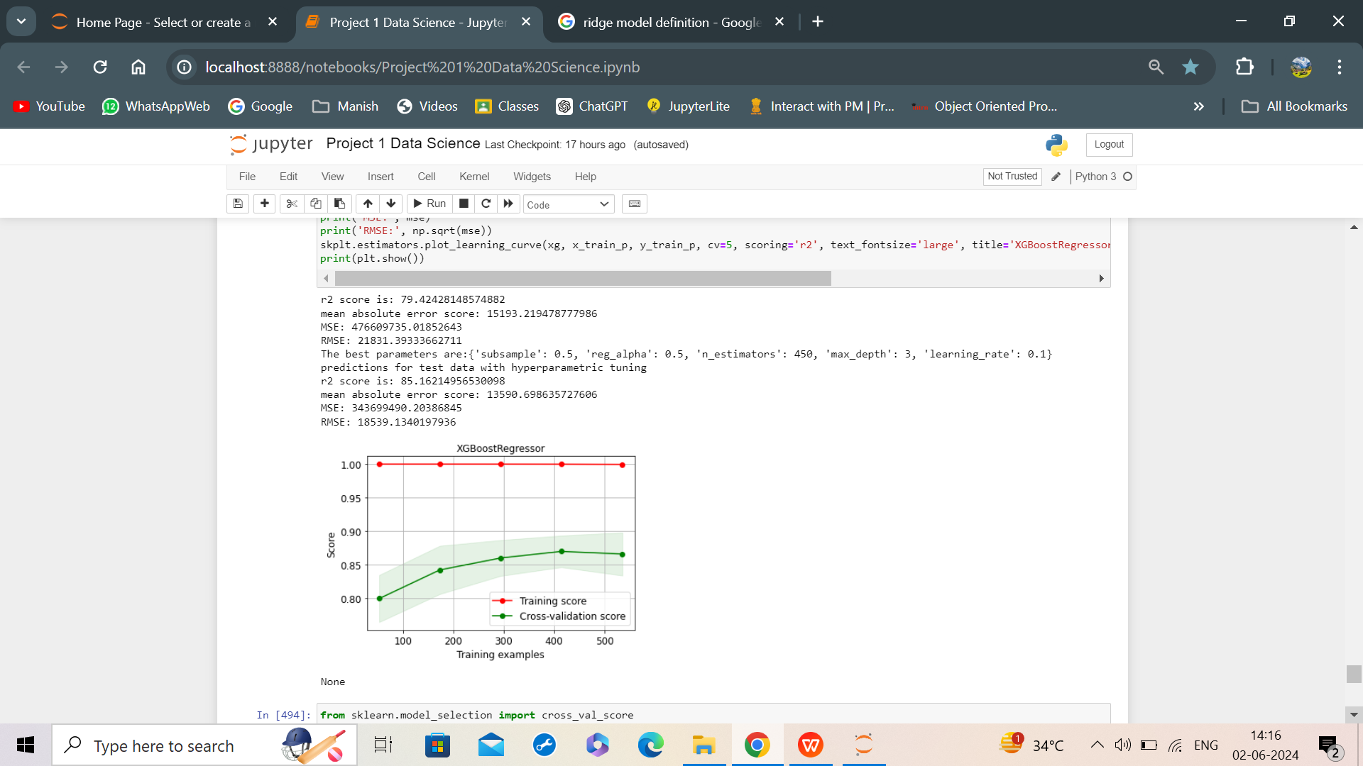

* By using the cross_validation_score, we see that:

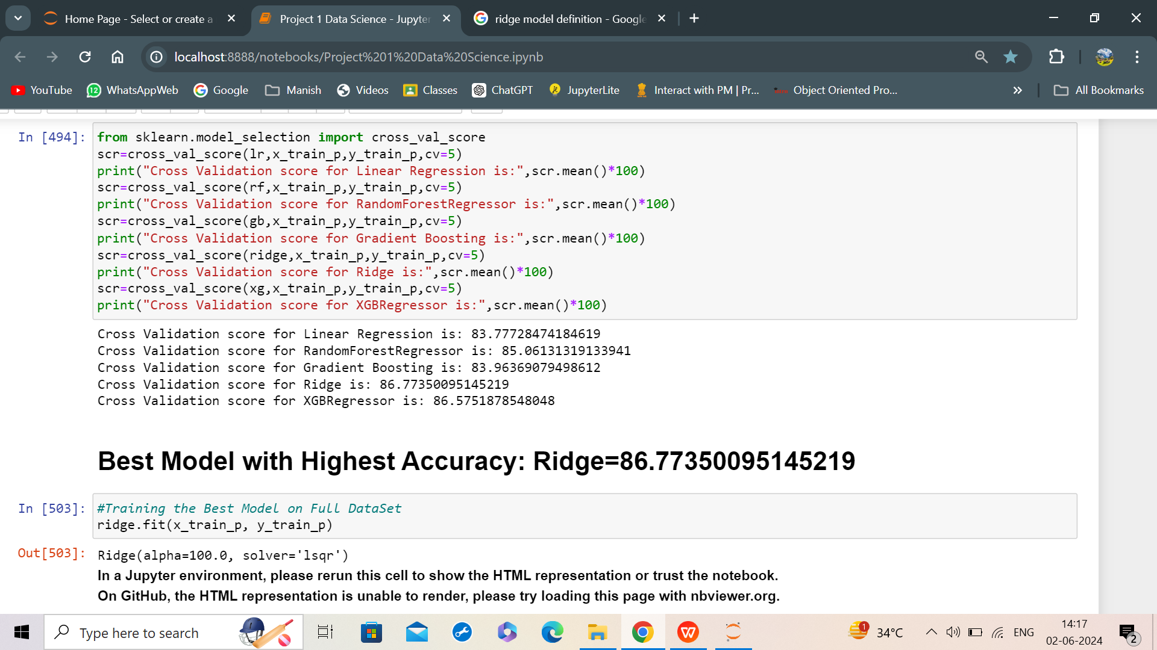

Hence, the order of efficiency of the models is:-

Ridge>XtremeGradientBoosting>RandomForest> Gradient Boosting>LinearRegression

* Ridge performed has the highest CV Score 86.773. It showed fantastic results for all metric evaluations. Hence, this is the best Machine Learning Model.

Feature Importance Analysis



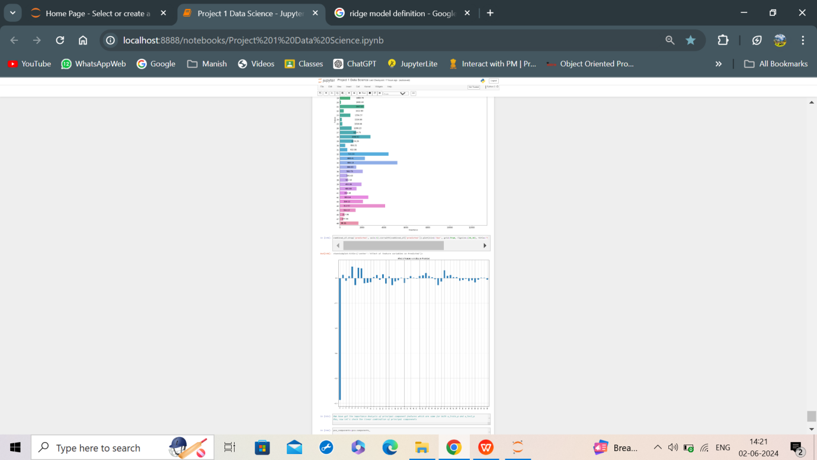

* Only, the zeroth feature had the most negative influence.

Business Implications

* This model will thus help, the customers to whether buy the house or not.
* It will help the society to assess its finance based on the SalesPrices.

Conclusion and Future Steps

* Hence, the project has made a model that has predicted the SalesPrice for the company to gain profit.
* However, there some market influences that can affect price rate which are nor mentioned here.
* The model could be improved by using more faster and better hyperparameter tuning methods, more no. of parameters can be passed with precise values to obtain an accurate working of the ML model.